FOR IMMEDIATE RELEASE

PRIVATE SCHOOL ABUSES EXPLORED IN
“A NEST OF SNAKES”

Debut novel weaves a tale snatched from the headlines
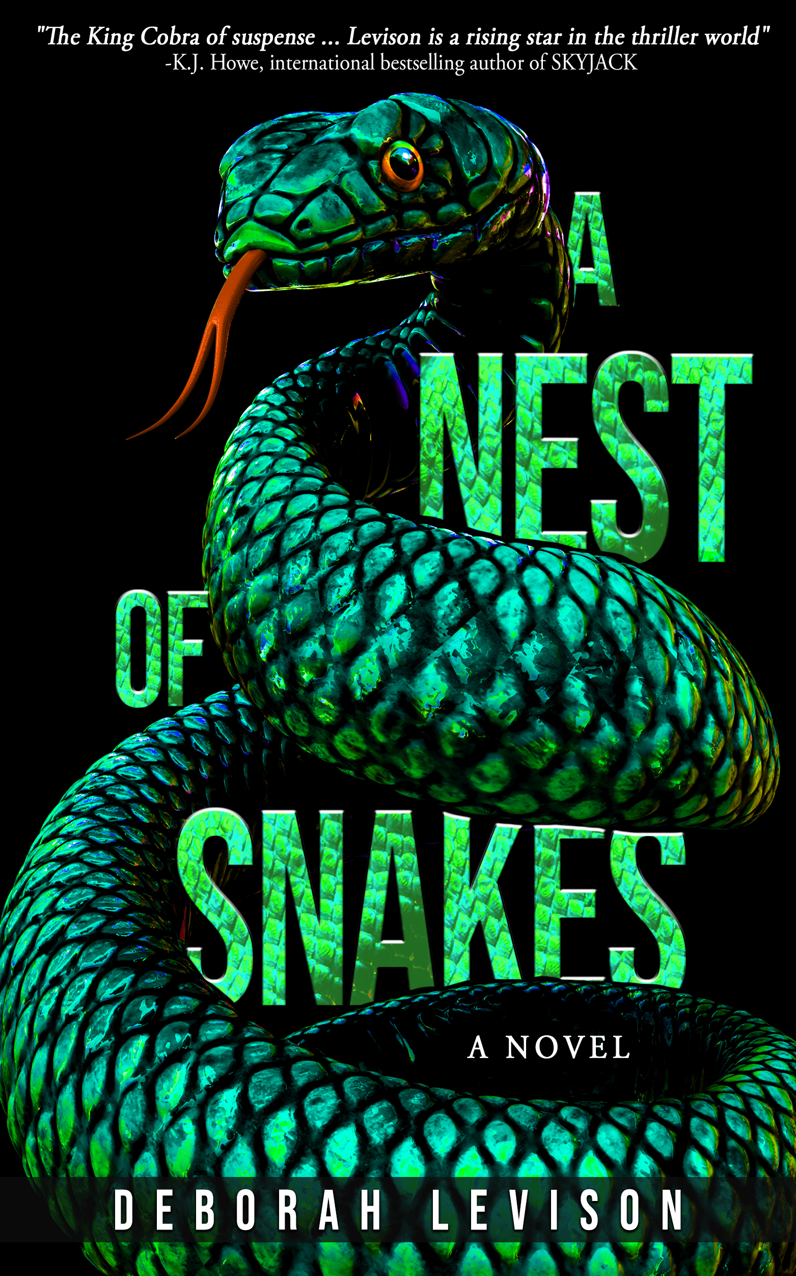
DENVER, CO., September 13, 2022 – Brendan Cortland is a broken man.

Middle-aged, pasty, pudgy, and fearful, he suffers from clear signs of post-traumatic stress. His contact with the outside world is limited to trolling clandestine chatrooms and a weekly session with his psychiatrist, who suspects catastrophic abuse—but in all his years of therapy, Brendan never divulged the deepest source of his trauma.

Pushed to his breaking point, Brendan finally embarks on a quest for justice: he files a lawsuit against the elite New England private school he attended as a boy. His attorney warns him that prepping for the case may mean dredging up the painful memories he’d rather keep buried.

Still, no one is prepared for the horrible secrets and shocking revelations that emerge during the trial… least of all Brendan himself.

A NEST OF SNAKES is the debut novel by multi award-winning author Deborah Levison (WildBlue Press, 2022).

Part thriller, part courtroom drama, the story is based on real-life events in which adult men came forward to accuse private schools of abuse.

It’s a timely topic: World media reported this summer that Denmark’s Crown Princess Mary and Crown Prince Frederik pulled their son out of his prestigious European boarding school amid allegations of rampant abuse and bullying. Students described a culture of physical violence and sexual abuse to which the school’s leadership turned a blind eye. It is precisely these issues that Levison tackles in her new novel.

Levison’s columns and articles can be found throughout North America and beyond. Her first book, a true crime story called THE CRATE, won seven literary awards. Reviewers hailed it as “gorgeous and poetic,” “heart-wrenching,” and “a brilliant story.” The Jerusalem Post said, “exquisite.”

“Both my books share similar themes of long-buried memories, and both trace the effects of violence and trauma over time,” Levison said. “I guess I’m drawn to writing about how terrible events in our past inevitably ooze up to the surface to haunt us.”

ADVANCE PRAISE

Evocative, timely, propulsive, and unforgettable, A NEST OF SNAKES is the King Cobra of suspense, striking when the reader least expects it. Levison is a rising star in the thriller world.
- K.J. Howe, international bestselling author of Skyjack

A heart-wrenching story of abuse and complicity, A NEST OF SNAKES intricately unfolds the horrors experienced at an all-boys private school and the aftermath decades later through the eyes of a broken man seeking solace and justice. With exceptional dialogue and an utterly compelling and gripping cast of characters, Deborah Levison delicately handles trauma and pain while keeping the reader coiled in anticipation for the perpetrators to receive their punishment. A powerful read from a dazzlingly talented author.
- Samantha M. Bailey, USA TODAY and #1 national bestselling author of Watch Out for Her

As a reviewer, it’s always such a pleasure to discover a writer whose style is fast-paced and doesn’t bog the reader down in details, whose storyline is fresh and different, and whose characters are unique and capture the imagination. For me, Deborah Levison is that kind of writer, and A NEST OF SNAKES is not one to miss if you enjoy psychological and/or legal thrillers. The story comes together perfectly with some very unexpected twists at the end. In short, Levison never gives her readers’ imaginations a dull moment! Terrific plotting and characterization make her writing a joy to read. Discovering Deborah Levison has been a real pleasure. I, for one, will be keeping an eye out for her next book.
- Reader’s Favorite 5-Star review

A NEST OF SNAKES is a raw, compelling story of abuse and all those it leaves in its wake. The protagonist, Brendan Cortland is a character for our times, damaged, strong and courageous as he faces the demons of his past and himself. Levison’s ending was unexpected and absolutely perfect. This book will stay with me for a long time.
- Colleen Winter, author of The Gatherer series

A NEST OF SNAKES is a beautifully told story about a horrible series of events that forever changed the lives of those involved. Heartbreaking, beautiful, jarring, and eloquent, Deborah Levison's novel spans decades and continents to speak of both the frailty and the strength of human nature. Be sure to set aside some time when you pick up A NEST OF SNAKES because you won't put it down until you've finished it.
- Desmond P Ryan, retired police detective and author of The Mike O'Shea Crime Fiction series

A NEST OF SNAKES is a massive leap from Deborah Levison's THE CRATE, which was an incredible true crime read. Its gut punch immediacy and emotional heft entrances the reader in a thriller that follows a sympathetic character who survived a horrific trauma in a boy's school. The jagged road that leads to a staggering climax propels the story forward like a rocket through a barbed wire gauntlet of emotionally-wrought drama, thrills, and deep characters that refuse to let go. A story both timely and powerful, Levison's strong writing should be one of the fall's most talked about novels.
- David Simms, author of Dark Muse and Fear the Reaper

Levison delivers a harrowing story of one man's fight for justice as he confronts the demons from his past. Haunting, suspenseful, and beautifully written, A NEST OF SNAKES is a disturbing look into abuses of power by those we trust the most.
- Anne K. Howard, author of the award-winning true crime story, His Garden: Conversations with a Serial Killer

In her debut novel, A NEST OF SNAKES, Deborah Levison boldly tackles a tough and timely subject: private school abuse. Part thriller, part courtroom drama, this gripping story is told in searing prose that propels the reader forward, right up to the last, jarring page.
- Gary M. Krebs, author of Little Miss of Darke County: The Origins of Annie Oakley

A compelling courtroom drama and a wrenching look at the horrific underbelly of an elite private school in the 1980s, Deborah Levison’s impossible-to-put-down new novel, A NEST OF SNAKES, takes the reader on a roller-coaster ride filled with surprising twists. Lawyer Dylan James is a woman you’d like to have in your corner, and plaintiff Brendan Cortland’s quest for healing will linger long after you’ve closed the book.
- Deborah Kalb, writer, editor, and book blogger

Brendan Cortland is a broken man. Broken by abuse as a child at an exclusive boarding school and the shame he felt. But in Deborah Levison's skillfully told novel, Brendan finds his path to redemption, first by tracking abusers online, and finally by going public and accusing his own tormentors. Heartfelt and horrifying, A NEST OF SNAKES is a story that must be told, and remembered.
- James R Benn, author of the Billy Boyle WWII mystery series

A NEST OF SNAKES is a taut and intelligent psychological thriller that will keep you reading well past your bedtime. Levison’s story and characters hook you and don’t let go.
- Tammy B. Bottner, award-winning author of Among the Reeds

A NEST OF SNAKES is full of twists and turns, several of them absolutely unthinkable, as Brendan recalls in court the physical, mental, and sexual abuse he endured at a private boarding school. After hearing some real-life horror stories concerning boarding schools on the news, I have to say this is a must-read for anyone who appreciates a good tale of psychological terror that could just as easily be true.
- Donna Marie West, author of Next in Line and The Mud Man

Deborah Levison's novel A NEST OF SNAKES grabs you from the first paragraph and takes you on a mesmerizing fictional journey. It shines a high beam on a hard topic: deviant behavior, people who live in shame because of it, and people who endure it. You'll cheer on some characters and be repulsed by others. Reserve a few hours to read this novel… like a snake that traps its prey, this novel will seize your imagination until the last page.
- Lauren Adilev, biographer, Turn Write This Way

In her novel, A NEST OF SNAKES, Deborah Levison weaves a suspenseful tale filled with psychological and legal insight. The book explores the long-lasting effects of childhood abuse, the evil perpetrated by those who abandon their responsibility to protect victims, and the path to healing. It packs an emotional punch that will stay with you long after you finish reading.
- Ruth Rotkowitz, author of Escaping the Whale and The Whale Surfaces

If you’re like me, you’ll keep reading this book until the middle of the night, and even then, you’ll want more! A NEST OF SNAKES is a propulsive page-turner, filled with twists and turns that will keep you guessing to the very end. Levison’s writing is a gift. A must-have for your TBR list.
- Sylvia Jacobs, book blogger

From a master of storytelling, Deborah Levison’s new novel A NEST OF SNAKES does not disappoint! I couldn’t put it down, and constantly toggled between shock, righteous anger, and awe while reading. It makes you realize there is much more to news headlines, and brings to life powerful, complex and nuanced characters as well as an important topic.
- Asha Dahya, TEDx speaker, producer and author of Today’s Wonder Women

Can a broken man who has lost almost everything find justice and cut through the nightmares that plague him? Deborah Levison – who is no stranger to exploring the dark shadows of reality – takes an unflinching and powerful look at horrific and unspeakable abuse in this emotional roller coaster ride of a debut novel. A NEST OF SNAKES opens with a lightning-fast strike and the intensity, compassion, and raw emotion of the story compel the reader forward, eager to see if escape, justice, or answers to the haunting trauma are possible.
- Mark Leslie, author of Fear and Longing in Los Angeles

Deborah Levison's page-turner A NEST OF SNAKES is a thoughtful, well-written and compelling exploration into the perennially vexing issue of child sexual abuse and the failure of adults to see and act.
- Meryl Ain, author of The Takeaway Men

A deftly-fashioned new brand of justice… this debut novel is book club worthy! Let’s hope A NEST OF SNAKES is the first of many more thrillers from Deborah Levison.
- J.L. Hughes, Author and Owner/Editor of Writers and Authors Craft Developmental Editing

Deborah Levison has created a real page turner with this novel. The story is gripping from the first line. Levison does a wonderful job of bringing out an inner strength in her protagonist that is wonderfully inspiring. You are not going to put A NEST OF SNAKES down!
- Heidi Slowinski, author of The House on Maple Street

BOOK DETAILS

A NEST OF SNAKES releases October 11, 2022 in print and e-book from WildBlue Press. To arrange an interview with the author or receive a review copy of the book, please contact WildBlue Press at promos@wildbluepress.com.

Deborah Levison is an award-winning journalist, publicist and storyteller. Her life has two parts: the first in Canada, where she attended University of Toronto, and the second in Connecticut, where she lives with three children, two doodles, and one husband. Visit her at www.debbielevison.com.

WildBlue Press is the premier independent publisher of true crime, thrillers, mysteries, sci-fi/fantasy, business books, and history books, in print, digital, and audio formats. Their list of bestselling authors includes John J. Nance, Steve Jackson, M. William Phelps, Burl Barer, and more.

ISBN 978-1-957288-40-6 Hardcover
ISBN 978-1-957288-39-0 Trade Paperback
ISBN 978-1-957288-38-2 eBook
Publisher: WildBlue Press Publish Date: October 11, 2022

